**PAGE1.HTML:**

<html>

<head>

<h2>Page1.Html</h2>

<form action="/action_page.php">

Name:<input type="text" name="Name"><br>

<br>D.O.B:<input type="date" name="d.o.b" max="2019-12-31"></br>

<br>Photo:<img src="WIN_20161223_12_50_25_Pro.jpg" height="100" width="150"></br>

<br>Password:<input type="password" name="*"></br>

<br>gender:<input type="radio" name="gender" value="male">male

<input type="radio" name="gender" value="female">female

<input type="radio" name="gender" value="transcender">transcender</br>

<br>hobbies:<input type="checkbox" name="hobby1" value="hobbies">reading

<input type="checkbox" name="hobby2" value="hobbies">singing

<input type="checkbox" name="hobby3" value="hobbies">playing</br>

<br><p><a href="page2.html">proceed</a>

</form>

</body>

</head>

</html>

**OUTPUT:**

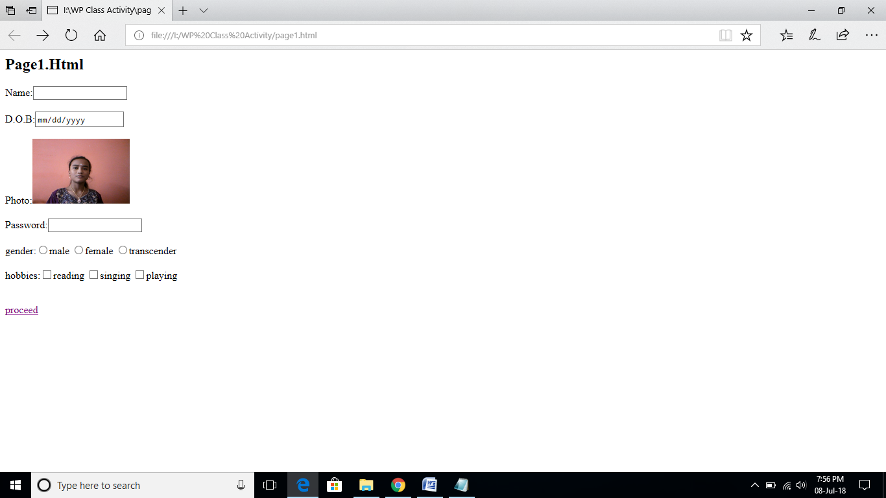

**PAGE 2.HTML:**

<html>

<head>

<body>

<h2>Page2.Html</h2>

<form>

contact:<input type="number" name="number"></br>

<br>country:<input type="text" name="country"></br>

<br>state:<input type="text" name="state"></br>

<br>city:<input type="text" name="city"></br>

<br>pincode:<input type="number" name="pincode"></br>

<br>mobile no:<input type="number" name="number"></br>

<br><input type="button" value="submit">

</form>

</body>

</head>

</html>

**OUTPUT:**

